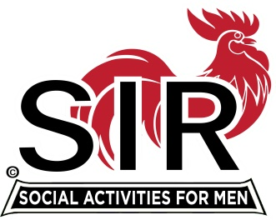
Las Trampas Branch 116
Luncheon Meeting Agenda
September 16, 2019, 11:30 AM

09:30 BEC Meeting
10:30 Social Hour
Greeters – Alan Pope & Chuck Vanoncini
Raffle – Don Benioff and Ben Bryce
New Member Orientation – Mike Schneider
11:25 Five Minute Call
11:30 Call to order; Opening Remarks – Big SIR
Pledge of Allegiance – Terry Grummitt
Chaplain – Pete Belden
Sunshine Report – Matt Arena
11:37 Story Teller – John Kopchik
11:41 Introduce Speaker – Alan Blavins –Fishing for Monsters
Guests – Recruitment - Don Schroeder John Alonso guest of Dennis Snarr; Scott Clark guest of Tom O’Brien
New Member Introduction – Jerry – Paul Russell, sponsor Gary Boswell
Recognize Greeters – Jerry (Alan Pope & Chuck Vanoncini)
11:45 Salad Served
11:46 RAMP Department Heads Reports and Activity Committee Reports
11:53 Reno Golf Awards and Report – Davy Harris and Paul Ramacciotti Awards – Certificate of Appreciation for Paul Ramacciotti
12:00 Lunch
12:35 Activity Committee Reports Remaining
12:40 Speaker – Alan Blavins – River Monstors
13:20 Speaker Thank You – Michael Barrington
13:22 Raffle Drawing - Ben Bryce and Don Benioff
Birthday Drawing – Little SIR
13:25 Sing Happy Birthday – Music - Robbie and Paul King
Sing God Bless America
13:29 Adjourn; Next Meeting, October 21, 2019

